Pioneers of Psychology
Structualism  _______________________________________  _______________________________________  Wilhelm Wundt:  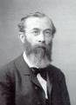 | Functionalism  ________________________________________  ________________________________________  William James:  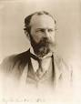
Psychoanalysis  ____________________________________________  _______________________________________  Sigmund Freud:  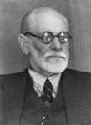 | Behaviorism  _______________________________________  _______________________________________  John Watson: B.F. Skinner:  